CAC Knights 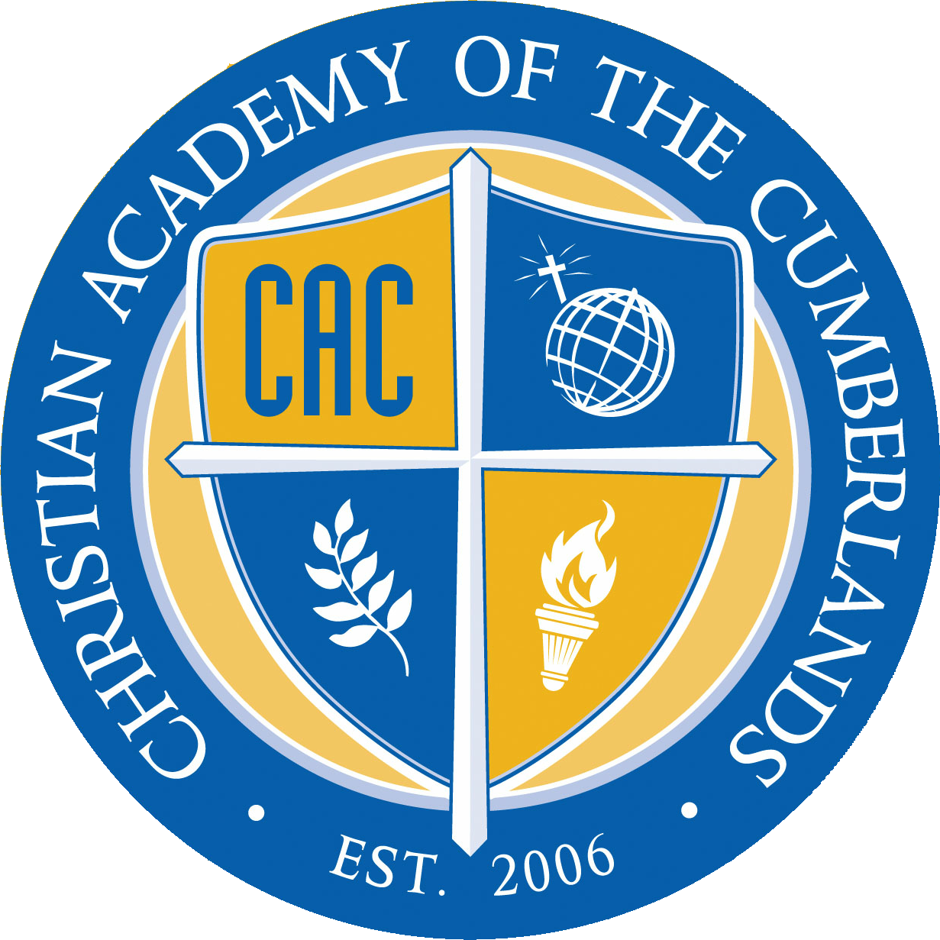 April | 2018

Sunday | Monday | Tuesday | Wednesday | Thursday | Friday | Saturday
1 | 2 | 3 | 4 | 5 | 6 | 7
EASTER | EASTER BREAK |  |  | Cross Country Race SMHS  4:00 | CAC  AUCTION  6:00
8 | 9 | 10 | 11 | 12 | 13 | 14
 |  | MATH OLYMPICS  CONCORD CHRISTIAN |  | SPRING PICTURES  Cross Country Race  3rd & 4th to Capital
15 | 16 | 17 | 18 | 19 | 20 | 21
 |  |  |  |  | Mid 9 Weeks  Year Book Money Due | Prom  6:00 – 10:00
22 | 23 | 24 | 25 | 26 | 27 | 28
EARTH DAY | IOWA  Mid-term Reports | IOWA | IOWA  Administrative Professional Day | IOWA | IOWA  Arbor day  Pre-School Musical 11:00  Variety Show 6:00
29 | 30

Isaiah 53:5 - But he [was] wounded for our transgressions, [he was] bruised for our iniquities: the chastisement of our peace [was] upon him; and with his stripes we are healed.
I thank God that my Lord did not stay dead after all that was done to Him. We should celebrate Easter with a fresh thought of the love and forgiveness we have in the RISEN SAVIOR!

