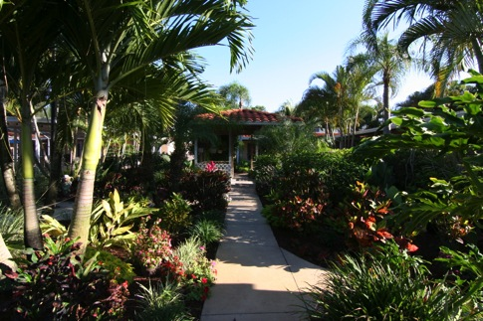

505 Menendez Street

Venice, Florida 34285

Patricia F Detwiler, Realtor/Consultant

Keller Williams Realty Wellington

12008 South Shore Blvd, Suite 201

Wellington, FL 33414

561.223.3201

Email: [PattieDetwiler@gmail.com](mailto:PattieDetwiler@gmail.com)

[www.BedandBreakfastConsultantService.com](http://www.BedandBreakfastConsultantService.com)

**Realtor/Consultant Disclaimer**

Keller Williams Realty, Bed and Breakfast Consultant Service and it’s representatives believe that the information herein is reliable, but it has not been independently verified nor guaranteed. Information is subject to change without notice. There may be additional information available to a purchaser from other sources. Purchasers should exercise all due diligence they feel necessary and should not rely solely on the information contained herein for the success of any future or contemplative business venture.

**Non-Disclosure of Material**

The information contained herein is of a sensitive nature. The owners of the property and business do not want this information to be shared with anyone other than for legal and/or tax advisors; this information is being released on the understanding that it will not be reproduced or disseminated without written permission of the Broker or Consultant/Realtor and only after agreeing in writing, to maintain the confidentiality of the information.

505 Menendez Street Venice, Florida 34285 United States

***Property Description***

505 Menendez Street is located on the beautiful Island of Venice, FL.

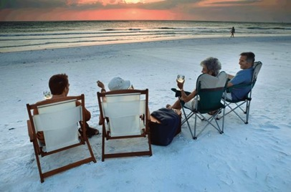The property is situated a short walk from the Venice Public Beach where the sunsets are lovely and the sharks teeth plentiful. The quaint historic downtown Venice shops and restaurants are also just a short stroll away.

The property has a variety of vacation rentals ranging from efficiencies, studios, one bedroom and 2 bedroom vacation accommodations with fully equipped kitchens and comfortable living rooms.

Venice is nestled between Sarasota to the north and Englewood, North Port and Port Charlotte to the south. Guests can go to one of the many of beaches; Brohard Beach, Casperson Beach, Nokomis Beach on Casey Key and Siesta Key Beach on Siesta Key which is rated the #1 beach in the country by Dr. Beach. Or enjoy a night out at the Venice Little Theatre, rent some jet skis or a boat at nearby Crow's Nest Marina or Gulf Harbor Marina, take a fishing charter, take a walk or a bike ride on the Legacy Trail that meanders along the scenic Intracoastal Waterway, go fishing at the Venice Fishing Pier or the South Jetty and of course hunt for shark’s teeth at all local beaches. If golf is preferred, Venice has several golf courses nearby as well, such as the Golf Club at Capri Isle, Heron Creek Golf & Country Club, Waterford Golf Club, Colusa Lakes Golf Club, Lake Venice Golf Club, and the Venetian Golf & River Club. Within a 30-45 minute drive guests can enjoy the local marine life at Mote Aquarium, visit the Ringling Museum of Art, Selby Botanical Gardens or G.WIZ Hands on Science Museum. There is also plenty of shopping choices nearby.

***Property Highlights***

* Turnkey offering
* Sales Price: $2,400,000
* 10 Units
* Zoning: RMF3 - RESIDENTIAL, MULTI-FAMILY
* 8268 Square Feet Living
* Sarasota County, Venice, Florida
* Beautiful outdoor Pool
* Patios and Garden Area

|  |  |  |  |  |
| --- | --- | --- | --- | --- |
|  | Occupancy | ADR |  |  |
| 2013 | 64% | $123.09 |  |  |
| 2014 | 72% | $127.60 |  |  |
| 2015 | 76% | $131.44 |  |  |
| YTD 2016* | 67% | $138.03 |  |  |
|  |  |  |  |  |
| *2016 YTD includes all reservations from 1/1/16 to 12/31/16 reserved | | | | |
|  |  |  |  |  |
|  |  |  |  |  |
| Bookings we currently have for 2017 business = $128972 | | | |  |

* Year Built 1961
* 0.43 acres of land

**Menendez Street**

* 505 MENENDEZ ST VENICE, FL, 34285
* **Land Area:** 18,750 Sq.Ft.
* **Municipality:** City of Venice
* **Subdivision:** 0540 - VENICE GULF VIEW SEC OF
* **Property Use:** 391X - Hotels/motels/lodging (1-40 units) - mixed use
* **Status** OPEN
* **Sec/Twp/Rge:** 12-39S-18E
* **Census:** 121150024013
* **Zoning:** RMF3 - RESIDENTIAL, MULTI-FAMILY
* **Total Living Units:**10
* **Parcel Description:** PARKVIEW APARTMENTS LOTS 12 & 13 BLK 40 GULF VIEW SEC OF VENICE

Buildings

| **Situs - click address for details** | **Bldg #** | **Beds** | **Baths** | **Half Baths** | **Year Built** | **Gross Area** | **Living Area** | **Stories** |
| --- | --- | --- | --- | --- | --- | --- | --- | --- |
| [505 MENENDEZ ST VENICE, FL, 34285](http://www.sc-pa.com/testsearch/Building/Show?strap=0176090029&num=1) | 1 | 0 | 5 | 0 | 1961 | 4,668 | 2,591 | 1 |
| [505 MENENDEZ ST VENICE, FL, 34285](http://www.sc-pa.com/testsearch/Building/Show?strap=0176090029&num=2) | 2 | 0 | 2 | 0 | 1962 | 960 | 768 | 1 |
| [505 MENENDEZ ST VENICE, FL, 34285](http://www.sc-pa.com/testsearch/Building/Show?strap=0176090029&num=3) | 3 | 0 | 2 | 0 | 1962 | 1,320 | 1,056 | 1 |
| [505 MENENDEZ ST VENICE, FL, 34285](http://www.sc-pa.com/testsearch/Building/Show?strap=0176090029&num=4) | 4 | 0 | 2 | 0 | 1963 | 1,320 | 1,056 | 1 |

Extra Features

| **line #** | **Building Number** | **Description** | **Units** | **Unit Type** | **Year** |
| --- | --- | --- | --- | --- | --- |
| 1 | 1 | CANOPY - Canopy (commercial) | 144 | SF | 1991 |
| 2 | 1 | PARKSP - Parking Spaces | 8 | EA | 1961 |
| 3 | 1 | PATIO - Patio - concrete or Pavers | 1500 | SF | 1991 |
| 4 | 1 | POOL - Swimming Pool | 392 | SF | 1991 |



