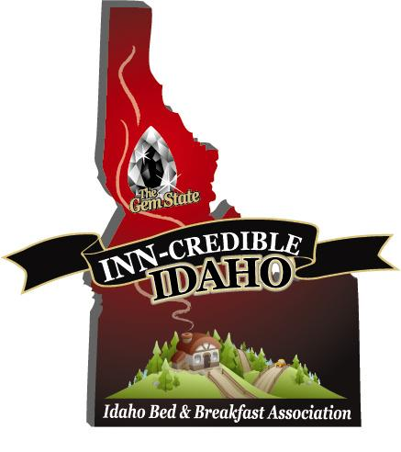

Newsletter #7 January 8, 2011

Attention all Idaho Small Lodging Owners

Just to review, a good time was had by all at the inaugural IBBA convention on October 13th here in Coeur d’Alene. I would have enjoyed seeing more of you and sharing the enthusiasm that is spreading for our new association! Please note that we will be accepting nominations for our 2011 “Inn-Spirational Innkeeper” award throughout August and September this year. We will have our convention information posted on the website much earlier this year so more of you can make plans to attend this October.

The website is now available for you to secure your password through the designer, Mary Kendall, at Mountain View Internet, and personalize your listing by adding all your property details, photos, specials, and recipes. Please contact her via email, her address is: support@mountainviewhosting.com or you may call her at 1-509-292-0841. For those of you that don’t have a website, our content management system will allow you to create your own mini website within the association site. Not yet a member? You are listed on the site, as a non member with just the name of your business, but you may not personalize your listing until becoming a member of IBBA. This is an invaluable opportunity for you to promote your business on the internet! Check it out at www.idahobba.com About ½ of our membership renews in January. I will send statements to our members as membership is up for renewal.

You will also have access to our business partners by becoming a member. By now, I hope all of our members have been contacted by our Association endorsed credit card processing company. Our newest business partner is offering their services in the field of small lodging insurance. If you have not been contacted, please let me know and I will give you that information.

We are excited to welcome the following ELEVEN new members for a total of SIXTY-TWO as of October, 2010:

Andriette’s Bed, Book & Bicycle & Brown Block Guest House both from Moscow
Dog Bark Park Inn & The Inn at St. Gertrude both from Cottonwood
A Walk On The Wild Side in Garden Valley
Pioneer Guest House in Weiser
May Family Ranch in Clayton
The Clark House in Hayden
The River Cove B&B in Post Falls
The Outback in Pierce
Boise Guest House in Boise

On the legislative front, look for some information in our next newsletter as our state senators and congressmen reconvene. Our Executive Coordinator Tina Hough, has been busy making connections with the state Fire Marshall and other officials in regards to requirements effecting our members.

We are contacting businesses throughout the state that you refer your guests to. Please don’t hesitate to call or email me with some of your favorites! We hope they will become lodging partners.

The next Grant application is due earlier than last year and Shar, our Grant Manager will be attending the Grant Summit in Boise on February 1st & 2nd to prepare our requests.

Join our great association! Our Association holds a large umbrella because we include Guest Ranches; Tent Cabins; Dude Ranches; Traditional B&B’s; Country Inns; Cottages; Guest Houses & Farm Stays. We would like to encourage all of you who are not yet members of our state Association to join, and get your business advertised on our website! Send your check, $75, made out to IBBA, to the address below or pay on line through paypal. We welcome your involvement as we continue to grow and meet the challenges ahead!

Brian Scott, President & Sharlene Scott, Secretary/ Grant Administrator
705 S. Zircon Lane
Coeur d’Alene, ID 83814
208-664-9650 Toll Free: 877-664-9650
info@americancountrybedandbreakfast.com
www.americancountrybedandbreakfast.com

