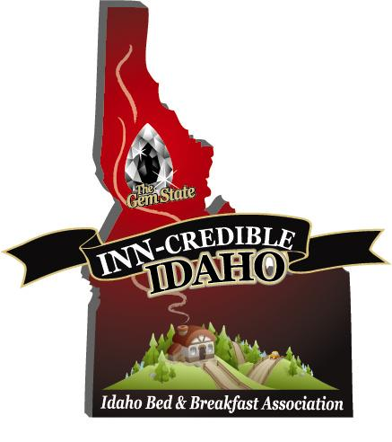

Newsletter #6 September 13, 2010

Attention all Idaho Small Lodging Owners
We have signed the contract with the Idaho Travel Council, (ITC), and have been working with our web site designer. The site is now available for you to secure your password through the designer, Mary Kendall, at Mountain View Internet, and personalize your listing by adding all your property details, photos, specials, and recipes. Please contact her via email, her address is: support@mountainviewhosting.com or you may call her at 1-509-292-0841. For those of you that don’t have a website, our content management system will allow you to create your own mini website within the association site.
Not yet a member? You are listed on the site, once your business is verified, but you may not personalize your listing until becoming a member of IBBA.

We would like to thank all of our 45 current members (see attachment), for their early commitment to the association! With their dues, we have blazed the trail to an ITC grant and a great website. This is just the beginning! For those of you that were waiting to see the website before you joined, hopefully, you will jump on board now! Take a look at this great site: http://www.idahobba.com We are also looking forward to working with Marsha Stearns on “Hot Leads” for all of the regions throughout the state!

SAVE THE DATE…WEDNESDAY, OCTOBER 13TH ! The self-funded convention will be held in Coeur d’Alene, starting at 6:00 P:M on Wed. evening with the option to attend the North Idaho Tourism Summit the following day. (For more information about the convention & summit please see attachments, or visit our website). We have secured nearby B&B lodging at a $65 convention rate or a trade exchange for our members. If there is anything you would like addressed on the agenda for the convention, please email us. This event will be an opportunity for us to share an in-depth look at the website, get the “Hot Leads” program rolling, and fine tune ideas for what we would like to accomplish in 2011! Mark your calendars now! Through your attendance, we will be able to select a site for the 2011 convention!

Join our great association! Our Association holds a large umbrella because we include Guest Ranches; Tent Cabins; Dude Ranches; Traditional B&B’s; Country Inns; Cottages; Guest Houses & Farm Stays. We are working with the Professional Association of Innkeepers International, PAII, to get a reduced rate for association members, partnering with credit card processors that would help us with reduced credit card processing rates and insurance companies that will help package insurance designed for small lodging owners. We would like to encourage all of you who are not yet members of our state Association to join, and get your business advertised on our website! Send your check, $75, made out to IBBA, to the address below and get a discounted rate for attending the conference. We welcome your involvement!

Brian Scott, President & Sharlene Scott, Secretary/ Grant Administrator
705 S. Zircon Lane
Coeur d’Alene, ID 83814
208-664-9650 Toll Free: 877-664-9650
info@americancountrybedandbreakfast.com
www.americancountrybedandbreakfast.com

