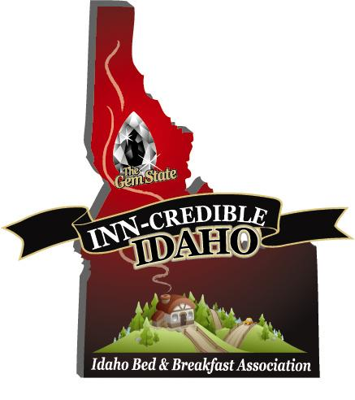

Newsletter #3 May 12, 2010

Thanks for the great response to our requests for membership! We are now approaching 40 members! All of our members should have received the IBBA Charter Membership Certificate, and have hopefully framed and displayed them prominently in their businesses. Included in that packet was a link with the widget instructions to place our beautiful logo on your personal website. Remember our B&B Association holds a large umbrella because we include Guest Ranches; Tent Cabins; Dude Ranches; Traditional B&B’s; Country Inns; Cottages; Farm Stays and other alternative lodging businesses that serve breakfast.

Recently, Shar Scott, American Country B&B and Tina Hough, The Roosevelt Inn, attended the ICORT conference in Boise May 4th and presented our Grant request proposal to the ITC travel council. They enjoyed our enthusiastic and informative presentation. It was an all-encompassing 10 minutes, as we are a new organization and the council needed to be informed of our purpose and who we represent as well as what we hope to accomplish. Because of our advance contacts, the ITC Council was very receptive and seemed supportive of our new association. Big thanks to Shar and Tina for the huge amount of work, time, and effort that went into this presentation, from the material compilation, to the 16 hours of driving. Another aspect of our organizational progress was the preparation of the IRS tax-exempt application, which was mailed out on April 28th with a return receipt request.

The IRS received the application on May 4th, and we included a letter for expeditious treatment. The cost to file this application was $850. BIG THANKS to the members who have joined as your dues made this possible. We’ve accepted a bid for the website construction, and we are awaiting grant funding notification to proceed with this project.

Your $75 in dues is a great investment! By joining, you can see what your membership dues have accomplished. Our future plans include the creation of a state brochure, and our first year convention. So, join now and be a part of this great endeavor!

We would like to encourage all of you who are not members of our state association yet to join! Send your check made out to IBBA to the address below. Please call me or email me with any questions or ideas you have for making this an all inclusive and effective association. We welcome your involvement in any and all levels!

Submitted on May 12, 2010
By Brian Scott, President & Sharlene Scott, Secretary
705 S. Zircon Lane
Coeur d’Alene, ID 83814
208-664-9650 Toll Free: 877-664-9650
info@americancountrybedandbreakfast.com
www.americancountrybedandbreakfast.com

